**Statistics Assignment 2**

1. How can we figure out what the interquartile range is?

Answer: -

- The IQR describes the middle 50% of values when ordered from lowest to highest. To find the interquartile range (IQR), first we have to find the median (middle value) of the lower and upper half of the data. These values are quartile 1 (Q1) and quartile 3 (Q3).

- Quartile 1 (Q1) is the 25% of the data whereas Quartile 3 (Q3) is the 75% of the data.

- The IQR is the difference between Q3 and Q1.

Formula: - **IQR = Q3 - Q1**

Quartile 2(Q2) 50% Median

Quartile 1(Q1) 25%

Quartile 3(Q3) 75%

---------------------------------------------------------------------------------------------------------------------------

1. What exactly is the value of the 5-number theory?

Answer: -

- The 5-number theory includes 5 items:

i. Minimum.

ii. Quartile 1 (Q1) (25%).

iii. Median Quartile 2 (Q2) (50%).

iv. Quartile 3 (Q3) (75%).

v. Maximum.

---------------------------------------------------------------------------------------------------------------------------

1. What is the relationship between standard deviation and variance?

Answer: -

i. Standard Deviation:-

- Standard Deviation is used to calculate how far our data is away from mean.

- Formula:-

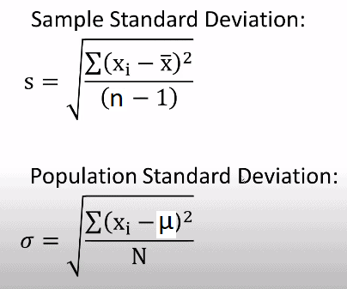

ii. Variance:-

- Variance gives the dispersion or spread of a dataset.

- Formula:-

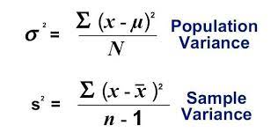

---------------------------------------------------------------------------------------------------------------------------

1. What does the difference between variance and standard deviation mean?

Answer: -

- The standard deviation is a statistical measure that people can use to determine how spread out numbers are in a data set. Variance, on the other hand, gives an actual value to how much the numbers in a data set vary from the mean.

- Standard deviation is the square root of variance, and the variance is expressed as a percent (especially in the context of finance). As such, the standard deviation can actually be greater than the variance since the square root of a decimal will be larger (and not smaller) than the original number when the variance is less than one (1.0 or 100%). Likewise, standard deviation will be smaller than the variance when the variance is more than one (e.g., 1.2 or 120%).

---------------------------------------------------------------------------------------------------------------------------

1. When is it appropriate to refer to a skewed data distribution?

Answer:-

- If one tail is longer than another, the distribution is skewed. These distributions are sometimes called asymmetric or asymmetrical distributions as they don't show any kind of symmetry.

- Symmetry means that one half of the distribution is a mirror image of the other half.

-----------------------------------------------------------------------------------------------------------------------

